Tuesday, 13 May 2025: Sustainability Management in the South Tyrol Region
Written by Hendrik Wolter

Our second day of the excursion began with a relaxed breakfast and check-out from the Youth Hostel in Bolzano. A brief and informative meeting prepared us for the day’s program. Each participant also received a note with a personal challenge for the day, which would be evaluated in the evening.

Our first stop took us, after a short walk through Bolzano, to IDM (Innovators. Developers. Marketers.), the destination management organization of South Tyrol, where we were warmly welcomed by Hannes Waldmüller. He gave us a detailed presentation of IDM’s fields of activity and sustainability strategies. Particularly interesting was how this relatively new organization unites various smaller tourism associations under one roof, creating synergies, especially between the agricultural sector and tourism, that are crucial for the region’s sustainable development. IDM is mainly funded by the local government (60%) and the chamber of commerce (40%), and now employs over 200 people across several locations in South Tyrol. Organized into different departments, IDM pursues clear objectives in marketing, business development, finance, agriculture, and corporate management. The professional and comprehensive structure of the organization was very impressive.
We were then introduced to the topic of sustainability in South Tyrol and why it has become especially important in the tourism sector. The region is increasingly affected by climate change, particularly impacting winter tourism. Additionally, overtourism leads to significant conflicts with the local population. IDM addresses this through targeted communication, including collaborations with influencers, to effectively spread sustainable messages. These conflicts are unsurprising given that South Tyrol has the highest tourism density in Italy and among the highest in Europe. IDM’s sustainability efforts currently focus on two main areas: destinations and accommodation providers. The work is based on GSTC criteria, which are also used in countries like Norway and Slovenia. IDM has developed its own sustainability label for evaluating the sustainability of businesses and destinations, awarded in three levels, with only the highest level fully meeting international GSTC standards. The aim of this certification is to provide a low-threshold entry while encouraging progressive improvement. IDM also offers various training sessions, workshops, and several digital platforms. “TourisMut” is a website that showcases practical examples and success stories from the region and international best practices. The “Change Maker” tool, developed in cooperation with TourCert, helps destinations pursue and improve their sustainability goals. It combines IDM indicators with GSTC criteria and provides practical tips, templates, and links.
Nevertheless, Mr. Waldmüller also emphasized major challenges, such as the gap between theoretical awareness of sustainability and the actual willingness to support it financially, both among guests and businesses. He also mentioned difficulties with the farmers’ lobby, particularly regarding the classification of agritourism. IDM increasingly relies on communication and dialogue among stakeholders to resolve these conflicts.
Unfortunately, we had little time left for an extensive Q&A session and discussion, as many more exciting program items awaited us.

After this informative morning, we enjoyed a joint lunch at Bar Ritter, a small, charming spot in downtown Bolzano. There, we sampled local delicacies like canapés and dumplings and shared our thoughts on the day’s learnings.

Strengthened, we joined an exciting guided city tour of Bolzano in the afternoon, led by Elisabeth Tocca. Elisabeth showed us the historical and cultural highlights of the city of 100,000 inhabitants, emphasizing Bolzano’s multicultural identity shaped by the, coexistence of Italian and German influences after a turbulent history. We learned many fascinating facts about the city’s development, originally established as a trading post between the Alps and the Orient. One interesting fact was that the city was raised several times after past floods, still visible today by the steps leading down to the entrances of older buildings. Elisabeth also explained a remarkable geological feature: Bolzano sits on an area once shaped by a giant volcano, the second-largest of its kind after Yellowstone.
Sustainability also plays a major role in the city itself, through measures like public fountains providing clean drinking water and the use of renewable energy, particularly hydropower, which provides local industry with inexpensive energy sources.

To conclude the day, we took the opportunity to individually stock up on groceries in town for the coming days before meeting again at the Youth Hostel to continue our journey to our new accommodation. Our home for the next two days would be Schweiggerhof, an agriturismo in the small mountain village of Villanders, situated in an impressive alpine landscape. We reached our destination via train and a stunning bus ride through endless serpentines, offering breathtaking views. There wasn’t much time to admire the beautiful and modern facilities, as we had a feedback session and a review of our daily challenges scheduled.

A shared cooking session and dinner in room groups marked the end of this informative and eventful day.

In conclusion, I would like to reflect on the day’s topic, “Sustainability Management in the South Tyrol Region.” Our visit to IDM showed us the importance of sustainability in the region, how it is strategically planned and implemented in destination management, and introduced us to some useful tools. Due to some lack of time, we couldn’t get deep into all the details. The group lunch and city tour of Bolzano were less focused on sustainability management but provided valuable insights into the region’s culture, cuisine, and atmosphere, helping us gain a comprehensive understanding of our surroundings for the next few days. Overall, the day was highly informative and engaging, offering valuable insights into sustainable strategies and local characteristics of South Tyrol.

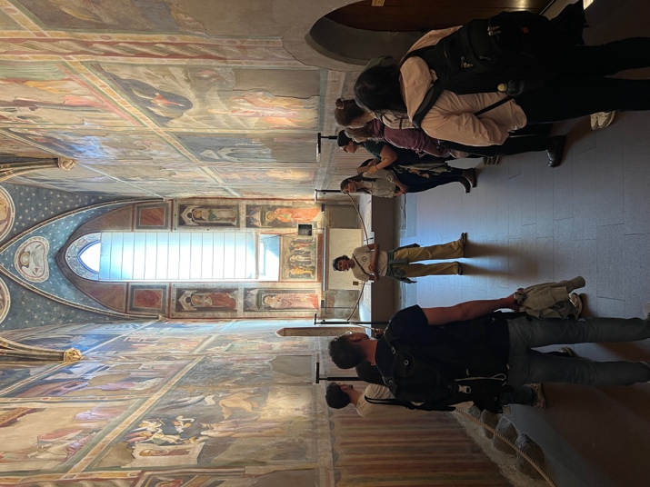
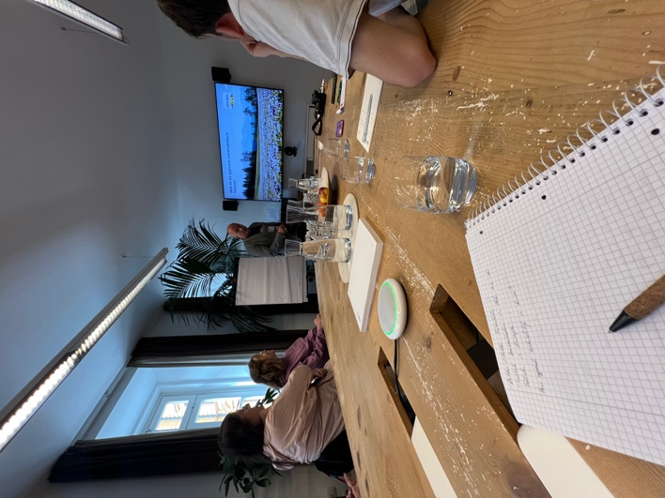

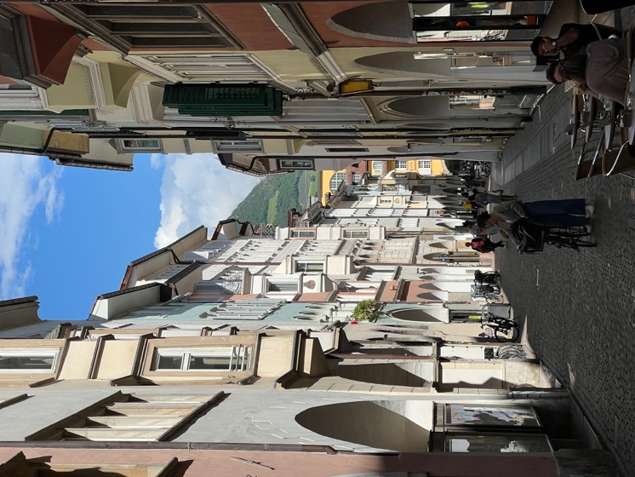

Wednesday, 14 May 2025: Synergies between agriculture and tourism, with a focus on local farm stays
Written by Hendrik Wolter

Our day began with an individual, followed by an online presentation in one of the apartments at Schweiggerhof.
Hannes Knollseisen introduced us to the South Tyrolean organization “Roter Hahn,” which supports agritourism enterprises. Roter Hahn handles marketing for 99% of agricultural businesses in South Tyrol, offering farmers an essential platform to expand their income opportunities beyond traditional farming. According to Hannes Knollseisen, “Roter Hahn” was founded because tourism and destination management organizations showed little interest in marketing farms, often being run by hoteliers. For that reason a separate brand was created that prioritizes authentic farm experiences and now offers a wide range of products and services. High quality and standards are emphasized, as the brand’s success depends on meeting customer expectations.
A brief look at the past revealed the origins of farm holidays, which was the result out of necessity. Wealthy inhabitants wanted to refuge from the summer heat in Bolzano and Merano and found it in higher altitudes, where only farms existed, with no tourist infrastructure. Later, this form of vacation became a cheaper alternative for less affluent people before evolving into a high-quality and well-established vacation model through targeted marketing.
Today, farm stays are considered one of the most sustainable forms of tourism, as small-scale operations, local production, and regional income flows make this form particularly sustainable and socially compatible. Tourism should also benefit the farms, making them more resilient through multiple income streams and promoting transparent, animal-friendly, and sustainable agriculture. These synergies are being further developed in current “Roter Hahn” projects, including barrier free tourism.
In addition to promoting farm stays, the organization also supports a cooking school to preserve traditions and facilitates knowledge transfer through workshops. “Roter Hahn” is funded 80% by membership fees from farmers and 20% by public funds, making it relatively independent from politics.

After learning about the background of farm holidays, it was time for us to explore our own farm stay, Schweiggerhof, through a guided tour with Magrit, the owner of the South Tyrolean agriturismo.

The farm originally focused only on dairy production, but starting in 1994, holiday apartments were gradually added. Notably, most of the construction was done by the family and their friends using wood from their own forest.

A wide variety of animals live on the farm: goats, sheep, chickens, cows, rabbits, guinea pigs, and even seasonal pigs. Feed such as corn and hay is grown on-site, which strengthens the farm’s self-sufficiency. One drawback from a sustainability perspective is that the farm has not transitioned to organic due to a lack of demand—an example of how market realities can influence sustainable decisions. During the tour, Magrit, speaking in a typical South Tyrolean accent (which was not always easy to understand), told us much about farm life, her children’s paths, and the challenges and developments of the farm. The many animals were a source of joy and affection in the group—some participants would have liked to adopt a few of them. Although the tour was interesting, it provided more general insights into the farm and lifestyle than deep input for a critical discussion.

Afterward, we enjoyed an extensive tasting session under the sunshine, featuring farm-produced eggs, milk, salami, Kaminwurz, fresh cheese, bread, wine, and bacon—all fresh and direct from the farm. This tasting not only offered culinary highlights but also a deeper appreciation for the value of local products.

Following a short preparation, we continued by bus into the mountains to the Villanders Alm. There, we first completed a group activity designed to help us get to know our classmates better. We then began a scenic hike past meadows and small huts, splitting up later according to preferred routes. One group aimed for a mountain ridge with a small church as the goal. The highlight was a breathtaking view over the valley and the distant Dolomite peaks. A short detour led us to an amazing mountain lake, still almost entirely frozen. There was just enough space to refill water bottles with clear mountain water, and some of us even attempted surfing on ice floes. A relaxed picnic at over 2,000 meters above sea level rounded off this impressive excursion before heading back to the accommodation.

In the evening, we gathered for a group feedback session, followed by dinner preparation in small groups in our apartments—a fitting conclusion to a varied and fulfilling day.

To conclude, I would like to reflect again on the topic of the day, “Synergies between agriculture and tourism, with a focus on local farm stays.” All in all, the day offered a perfect mix of theoretical insights, practical experiences, and immersion in nature, a vivid look into the sustainable connection between agriculture and tourism. The choice of accommodation suited the topic perfectly, as we were able to experience it firsthand. Even though our hike did not provide any academic input on the topic, it was still a pleasant recreational break and allowed us to experience the “vacation” aspect of the theme firsthand. Overall, the topic, the combination of agriculture and tourism, is very engaging and not commonly addressed in our studies. Our impression today was that this segment is gaining importance and is considered one of the most sustainable forms of tourism. Tomorrow, we will explore more aspects of this topic, and we’re curious to see whether this impression will be confirmed.
